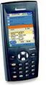Eleven ESM
Functional Specification

Copyright © 2005, Eleven Technology

B. Hodgson | 001: 10/17 – Created. First screens of Manage Work List
  001: 10/17 – Created. First screens of Manage Work List
 | 002: 11/16 – Added content from work shop, internal design review, and service call wizard updates.
  B. Hodgson | 001: 10/17 – Created. First screens of Manage Work List
B. Hodgson | 003: 11/21 - Added in high level descriptions, process flows, and state diagram from PRD doc.
B. Hodgson | 004: 11/23 – Added simplified Start of Day/End of Day, Removed BoD/EoD button from dash, added Maint button color changing for master data updates and new software available.
B. Hodgson | 006: 12/4 - Incorporated details from review in Vienna (Nov 28-Dec 2)
B. Hodgson | 007: 12/22 - Incorporated comments for final approval and sign off. Updated off rout to show equip choices when creating off route, added pop-up for admin sign on. Clarified requirement around outlet and equipment information on the device –resulted in prompt when creating off route for download, or alternatively ca ndo a pull from account card detail page.
B. Hodgson | 008: 12/23 Changed Open button on outlet visit screen to Open Activity, added equipment list button fromnew offroute creation screen to start service call screen as well. Included user access to OS and other applications as an issue to be resolved.
B. Hodgson | 1.0: Jan 12/2006: Corrected description about downloaded outlet and equipment details.

Open Issues

- Off-route service calls cannot be sent to BASIS until the work report is complete. To be determined whether these are synched to the consolidated as other service calls or held until complete. Either way these cannot be sent to the connector until the work report is complete.
- Currently a technical design issue whether a new software download is one step or two.
- The comm parameter screen is a placeholder.
- Access to OS and other applications for users who are configured with this ability. Technical solution is being developed, and any updates to functional spec will be incorporated. (There may be a solution uses the mapping to hardware buttons functionality of WinCE. this button mapping would enable users to open identified applications like calendar, address book or phone. this O/S customization will be done by the local I/S staff before giving the devices to reps. a final confirmation has not yet been made...)

Contents
Open Issues ii
1. Overview 5
Overall Process Flow 6
Service Call Process Flow 8
2. Main Menu 9
Overall Screen Flow 10
Main Menu 11
3. Manage Work List 12
Work List 13
Service Call Details 14
Add Service Call – Creating Off Route 15
Add Service Call – Get Outlet/Equipment Data Onboard 16
Find Outlet 16
Outlet Visit 17
Perform Service Wizard 19
Perform Service Wizard - Step 1 20
Perform Service Wizard - Step 2 21
Perform Service Wizard - Step 3 22
Perform Service Wizard - Step 4 22
Perform Service Wizard - Step 4a – Parts Search 23
Perform Service Wizard - Step 4b – Parts Search Results 24
Perform Service Wizard - Step 5 24
Perform Service Wizard - Step 6 25
Perform Service Wizard - Step 7 26
Perform Service Wizard - Step 8 26
Perform Service Wizard - Step 9 27
Perform Service Wizard - Finish 27
4. Outlets and Equipment 28
Outlet List 29
Outlet Details 30
Outlet Equipment List 31
Equipment Details 32
New Equipment Found 32
Equipment Service History 33
Outlet Service History 33
5. Spare Parts 34
Spare Parts 35
6. Begin/End Day 36
Overview 37
Start of Day/End of Day/Interrupt Day/Resume Day 38
Start of Day/End of Day/Interrupt Day/Resume Day 39
Sign On 40
Sign Off 40
Daily Summary 41
7. Info Center 42
Message Summary 43
Received Message Detail 43
Send Message 44
8. Admin 45
Admin - System 46
Admin – Pref 46
9. Sync 47
Sync 48
Sync – Comm Settings 48
Grid Configurability 49
Equipment Scanning and Masks 49
Configurable Exception Warning Levels 50
Transaction Data Purge 50
Printed Work Report 50
Odometer Default Values 50
Soft Keyboard 50
10. Appendices 51
Appendix A – Handheld Service Call States 52
Appendix B – BASIS Service Call Types 53

Overview
Bottlers have a team of technicians who service, install and repair equipment. Each service technician has typically a geographical region assigned for which he is responsible. Some technicians also work in the warehouse to refurbish or prepare equipment for installation. Usually there are multiple teams of technicians specialized in a type of equipment or in a type of work, typically one team looks after vending machines and another team looks after fountain equipment and coolers. Initially there will be no difference in handheld functionality between these teams of technicians as the back-office will handle through the dispatching process.

It is also possible that equipment service is done by third party service agents who get paid with rates based on the type of equipment and type of work. Agents can either request a service activity from the call center, or they get a service activity assigned, just like an employed technician. Both, employees and third party agents, are potential users of the mobile ESM solution.

Initially, there will be no difference in functionality in the handheld whether the user is an employee or third party agent. The only exception to this is for creating off-route service calls. Users will be limited to only being able to create off-route service calls for themselves for equipment that they are qualified to service.

Overall Process Flow
The overall process flow is show below.
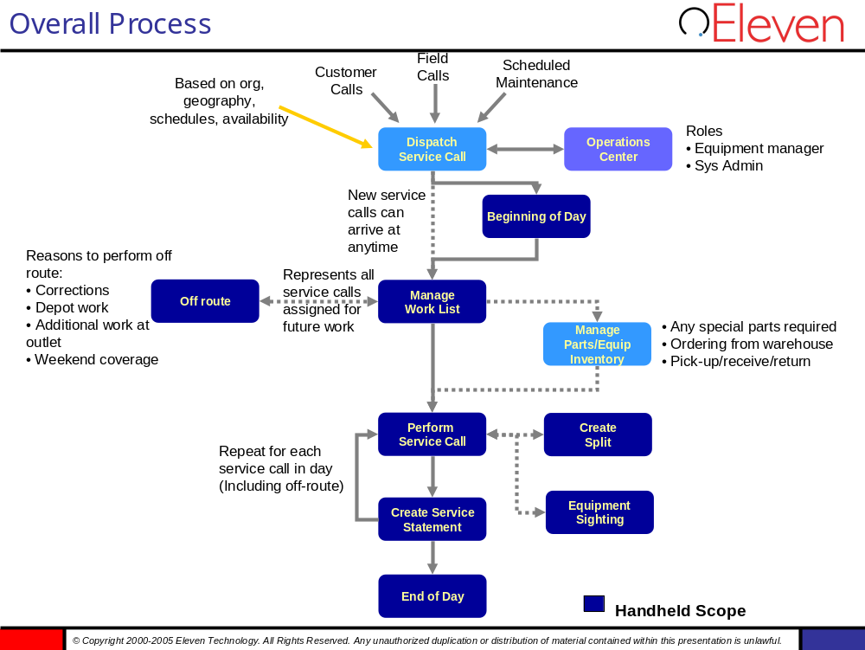

The inputs to the process come from customer calls, preventative maintenance, or calls from other reps (sales, delivery, etc.) The types of calls include:
- Break/fix – Typically unplanned, higher priority is given based on customer, operational impact, and customer revenue.
- Install/Remove/Move – Planned activities for example restaurant opening and new fountain equipment must be installed.
- Preventative maintenance – Periodic maintenance

Reps start of day varies as many leave directly from the home to their first account, others may go to a service depot in the morning. Requirements for the handheld are to capture starting odometer and time.

The work list is the set of service calls that the technician is responsible for based on their geographic coverage, their skills (do they service fountain as well as vending, etc.). The dispatch process is responsible for ensuring the right service calls are assigned to the right reps. The rep is responsible for managing the service list in terms of priorities, order of servicing customers, determining parts required, etc. Based on the reps workload they may reject assigned service calls (configurable). There are cases where a rep can create a service call without assignment from the dispatcher. These are referred to as offroute service calls. There are a number of scenarios when a rep may create an offroute:
- To correct a completed work report (for example the entered using 100 parts by accident instead of 10)
- They at an outlet and the manager asks them to fix a piece of equipment in addition to the one in the service call which resulted in them being at the outlet.
- Depot work
- Off hours coverage. There are cases for extended service coverage that there is no dispatcher on duty and customer calls get routed directly to the rep.

If the reps start a service call (start travel), and do complete the work involved, they must complete the service call, makr it as incomplete, which results in the call getting “split”, whereby a new service call is created to complete the work. The newly created (split) call may be assigned back to the rep or to another rep. There could be multiple reasons for a split (lack of parts, store closing, etc.)

Finally, an equipment sighting may be requested of reps when they visit an outlet for a service call. An equipment sighting is simply ensuring all the expected equipment at an outlet is still there, and may optionally include verifying key attributes of this equipment such as serial number, model type, etc.

Service Call Process Flow
For each service call the following high level process is followed:
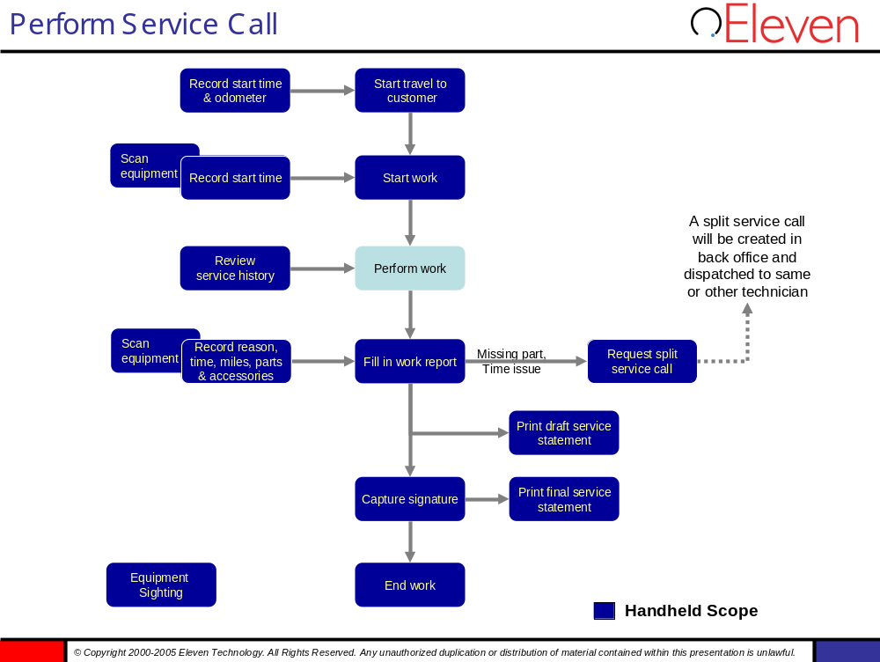

Main Menu
The Main Menu is the point of entry for the entire application and includes the main menu and link to end of day summary reports.
. The Main Menu can be configured at the control level (turn buttons on and off, change the order of the buttons on the screen). The application settings provide options ranging from on/off switches to numeric and text values that are used throughout the application to customize the screen flow, messages and various other pieces of functionality. Also, the entire application can be customized from a UI perspective through a skin file that stores your corporate logo, control colors, fonts and other icons used throughout the application.
.

Overall Screen Flow
Main menu provides access into the following hubs
- Manage work list – provides means to view, sort, filter new, service calls. For new service calls the user can accept service calls or reject service calls. From the work list the user would also have visibility to the associated service call details, equipment, and outlet details. From the work list the rep can initiate accepted service calls, and create new service calls for off route activities.
- Outlets – provides a view into all the outlets downloaded to the handheld. These can be searched by outlet number, name, address, city, etc.
- Spare Parts – Provides visibility to rep’s spare parts as sent from the BASIS. As parts are used/returned in service calls these quantities are decremented/incremented, repectively.
- Start of day/end of day – Provides ste of start and end of day tasks.
- Admin – Provides access to software updates and preferences
- Sync – Allows sync by data category and the setting of sync parameters.
- Info Center – provides view and send to messages.

The high level screen flow is show here:
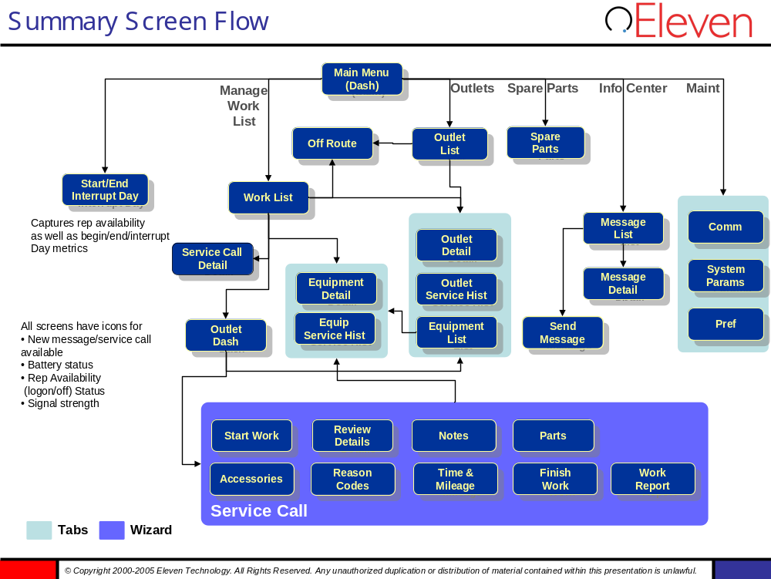

The header of all screens will contain the following icons and functionality
- New information available at server – Indicators shows whether there are new service calls and/or messages on the server to be synched This includes new, changed or deleted transaction. The deleted case is from the rep’s perspective - the service call could actually have been assigned to another rep. The rep can view the details and decide to synch immediately or wait. In the case they wait the icon remains until they perform the synch. Once the synch has been done the icon is not visible. A successful sync of a service call sends a message to the back-end.
- Battery status – indicator showing percent left of battery charge
- Rep availability – rep can toggle themselves as available or not available by tapping on this icon. This sends a message to the BASIS. This was formerly called logged in. Default setting when signing on to application is to set rep available.
- Signal strength (not shown) – Shows wireless signal strength based on rep location.

Main Menu
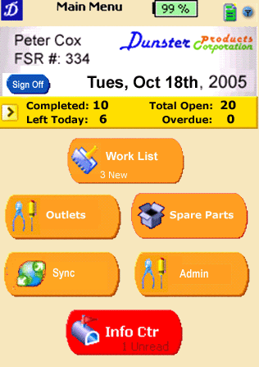
Description of Functionality
- Main dashboard of application where user lands after application sign-in.
- Rep name and ID appear on dash. If the rep is signed on as admin this should be highlighted. When Admin is signed on icon for accessibility to PocketPC menu
- Summary of day’s service calls appears, with ability to review past EOD (end of day) summaries by clicking on metrics bar.
- Manage Work List turns red if any overdue service calls exist.
- Info Center turns red if any unread messages
- Maint button turns red if there is an software update available for if master data has not been sync’ed in X days as configured (in server).
- Logo and colors are configurable.
- Date format is localized

Manage Work List

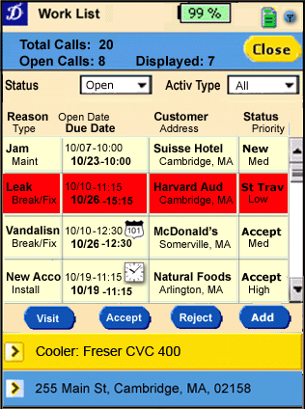
Work List
Description of Functionality
- Provides rep visibility to all open and completed service calls.
- Filter selects the service calls that appear. .
- Status filter choices available include specific statuses New, Accepted, Started Travel, Started Work, Complete. In addition , Open is available which shows all above statuses except complete. Overdue shows any service calls that are where due date is in the past (see below). Also All shows all service calls.
- Header shows total number of calls in rep list (assuming no filter), number of open service calls, and number visible based on filter criteria. For example, the the rep has 20 calls, with 8 complete, and 12 open. In addition they filter on break/fix and open which results in a list of 4 calls, the header would show List Total=20, Open List=12, Displayed List=7
- When a row is selected the associated equipment and outlet are highlighted at the bottom. The equipment tab should model description. The outlet tab should show address city, state/prov, phone number.
- Any overdue service calls are shown as RED (or similarly equivalent indicator – font, icon). Every activity gets a due date and due time which is not available in BASIS and will be calculated for as follows and provided as part of the integration:
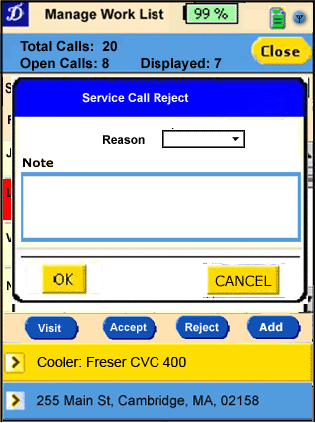
- Installs/Removes/Moves: scheduled date (entered by dispatcher in BASIS)
- Preventive Maintenance: scheduled date (entered by dispatcher in BASIS) + number X days. Where X is configurable per installation.
- Break-fixes (call-ins): configurable whether it is calculated from Open date or from Scheduled date in BASIS. A configurable number of hours can be added based on service priority, e.g. 0 = 2 hours, 1 = 4 hours, 2 = 8 hours, 4 = 24 hours, 5 =48 hours, 6 = 72 hours
- A service call becomes overdue when work has not been started until the due date/time
- Off route activities are shown with an off route indicator.
- Actions
  - Accept – only available when status=New
  - Reject – only available when status=New or Accepted. Reject requires a reason code. The rep can optionally update the technician note (of there is an existing note it can be edited or overwritten) Becomes delete if off route is selected. Off route activities can be deleted up until the time they are completed.
  - Add - Creates off route activity.
  - Visit – Takes rep to outlet visit This is disabled unless the service call is in one of the following states: Accepted, Started Travel, Started Work, Complete. In the case of Complete the store visit service call details are read only.
  - Close – returns user to main menu.
- Default sort order of the list should be due date, then priority (rep priority – which defaulted dispatcher priority). ,. No user controlled sorting.
- Double tapping on service call takes rep to service call details
- The user can tap on the equipment bar and they will be taken to the equipment details screen.
- The user can tab on the outlet bar and they will be taken to the outlet details screen.
- When returning to this screen the service call selected should work as follows
  - From main menu position to first item in list
  - When coming from outlet visit, and service call is not complete position to same service call.
  - When completing a service call position to next item on work list.
  - When creating New (off route) and do not “Start Work”, this new service call should be selected upon returning to this screen.
  - From any other (outlet detail, view, equipment detail, new service call that gets cancelled) should position to service call that was selected when leaving this screen.

Configurability
- Filter criteria
- 2 fields on main screen
- Auto accept – New service calls are accepted automatically. Accept and reject buttons become grayed out. Configurable per installation. During implementation, this status could be renamed to something more appropriate than “Accepted”
- Sorting of list. Configurable per installation.
- The number of days from scheduled date for preventative maintenance.
- The number of hours to add to the start time for break/fix based on priority.
- Which attributes are displayed in grid

Service Call Details
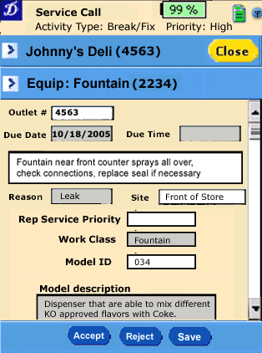
Description of Functionality
- This screen is reached by by double clicking on the service call in the work list.
- Provides rep ability to view details of service call. Primary objective is to provide more details to help them determine whether they should accept or reject the service call. Provides all service call attributes as configured. Attributes (other than technician note) would be read only.
- Actions
  - Accept – only available when status=New
  - Reject – only available when status=New or Accepted. Reject requires a reason code (same pop-up as on manage work list)
  - Save - Saves any changes
  - Close – take rep back to work list. Error/warning if close is done without saving after changes have been made.
- The user can tap on the equipment bar and they will be taken to the equipment details screen.
- The user can tab on the outlet bar and they will be taken to the outlet details screen.
- In case where auto accept is configured, accept and reject are inactive.

Configurability
- Which attributes appear on screen
- Which attributes are editable by rep. Specifically, rep priority and schedule time are definite requirements to be configurable whether the rep can update. Outlet number is not editable.
- Same auto accept rules apply as on the work list.

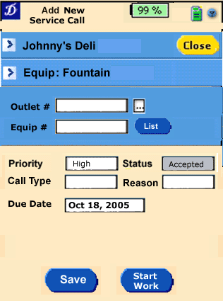
Add Service Call – Creating Off Route
Description of Functionality
- This screen is reached by tapping on the “Add” button on the Manage Work List screen
- Prompt to create an off-route by selecting an outlet, and/or optionally equipment number.
- Scan equipment fills in equip #. If scan fails rep can fill in equipment number manually. The outlet number should be populated based on master data.
- Alternatively, the user can enter the outlet number. If the rep does not know the outlet number they can search their outlet list by customer name, address, city, state/province, and select an outlet from the list.
- Based on the entered outlet number the rep could press the List button to see all equipment currently installed at that outlet and select an equipment from the list. The List button is only enabled if a valid outlet number is present in the Outlet # field.
- If outlet and equipment are populated consistent with master data, the outlet and equipment tabs become active.
- Actions
- Save – Adds service call to work list in status accepted
- Start Work – Takes user to outlet visit and status is Started Work
- Close – No new service call is created. Rep is returned to work list. If rep closes after entering some fields they are prompted with a warning.
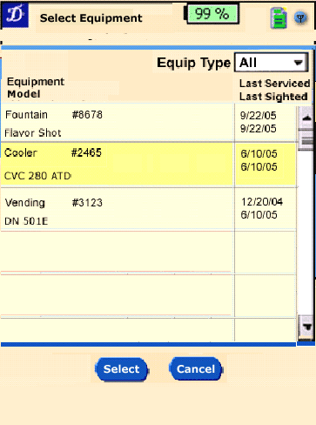
- Upon “save” or “start work” in the case where the master data does not show equipment as present in the outlet (e.g. they have entered an outlet number then scanned) a configurable error/warning is generated. If the technician accepts the warning an a possible mismatch would be flagged in the connector if it still exists. The connector will retry again without the equipment number (TECH NOTE: Off-route service calls cannot be sent to BASIS until the work report is complete. To be determined whether these are synched to the consolidated as other service calls or held until complete. Either way these cannot be sent to the connector until the work report is complete). In the case where the equipment number and outlet are inconsistent with master data. The outlet visit dash for the off route service call should be that of the outlet entered here.
- Default values on off route service call
- Highest priority
- Due today

Configurability
- The rep can be limited to create service calls for certain service call types. Service call types are customer defined. Appendix A shows those supported by BASIS. This is configurable per service location.
- Equipment number masks for scanning (see Equipment Scanning and Masks in chapter 9. Sync). If more than one mask applies the tech can select one in a pop-up window (same as in Perform Service wizard – Step 1)

Add Service Call – Get Outlet/Equipment Data Onboard
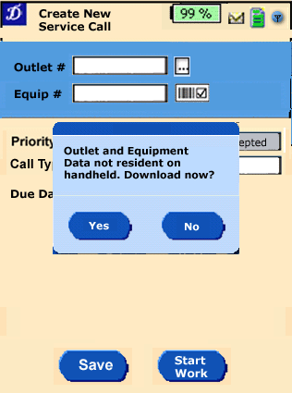
Description of Functionality
- This pop-up is reached if the rep requests an equipment list from the Add Service Call screen. Valid outlet number not onboard
- Prompt use when outlet and equipment data is not resident on handheld.
- Actions
- Yes - initiates a download of outlet and associated equipment to handheld.
- No – No download is performed. Service call is still created with field specific. Outlet & equipment is loaded as background sync of data for assigned service calls.

Configurability
- None

Find Outlet
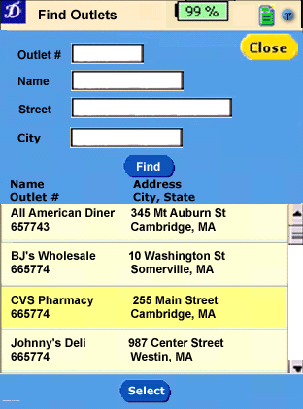
Description of Functionality
- This screen is reached from the create new service call screen, when the rep wants to search for outlets..Design Note– use more real estate for lists of outlets
- The outlet list starts empty and is filled when “Find” is tapped.
- The rep can search by
- Outlet number
- Name – name of outlet
- Street – Number and street name.
- City – City in which outlet is located.

Entries are logically ANDed together. Partial entries can result in multiple outlets found. For example, entering CVS in name could resulting in finding CVS Pharmacy and CVS – Connecticut Vocational School. The entered outlet number is also applied as wildcard, e.g. 800 finds 800237, 128005 and 9800 (used at CCEAG). BJH-Nice to have

- Actions
- Find – applies the input filter criteria and populates the outlet list
- Select – Enabled only if a row in the list is selected. Selects the outlet add enters it into the outlet field on form from which this was launched.
- Close – returns without selecting an outlet.

Configurability
Issue – does Search criteria need to be selected from available outlet attributes Name and address as defined in thin outlet table.

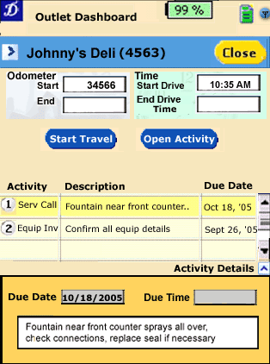
Outlet Visit
Description of Functionality
- This screen is reached from by tapping the visit button on a service call from the work list. Provides a view of the activities that should be performed at this outlet.
- The service call that was selected from work list to arrive is designated the primary activity. This is used to allocate travel time and mileage. For this release only service call activity types could be primary. This allocation sets the default mileage and travel time for this activity. These could be overridden within the service call wizard when completing the work report, or allocated to other service calls within this visit. No validation across service calls that totals add up to mileage and drive time totals captured as part of start travel. If there are additional service calls the travel time and mileage for these are defaulted to zero. It is up to the rep to determine the allocation of times when multiple service calls are performed.
- When Started Travel state is configured on, this captures start and end odometer and start and end drive time for outlet trip.. Drive time for the primary activity is defaulted based on start and end drive time when end drive time is filled in.
- If Started travel state is turned off no odometer or drive time metrics are shown (back-end requires start travel timestamp, so in this case this should be set to start work time stamp), and Start Travel button is simply Start Work.
- For first service call of the day, odometer should default to start of day odometer reading. For subsequent service calls the staring odometer should default to the ending odometer of the previous service call. End odometer must be greater than start odometer
- List of activities is shown. Selecting the activity displays details of the activity. Additional details can be viewed by clicking on the “Activity Details” window shade”. Supported activity types are: Serv Call (service calls either assigned from dispatcher or created as new by rep), and Equip Inv (Equipment Inventory – process of inventorying all equipment in an outlet and checking key attributes for accuracy such as serial number, model, etc.) There could be 1 or more service call in the list. Equip inv would appear only once. If the due date has passed for either of these activities they are shown as RED (or some equally prevalent indicator) The activities are ordered with primary activity first (and default selected) followed by activities sorted by due date. As activities are completed the left icon showing their number in the list becomes green.
- A preview of the activity details is shown at the bottom this screen. The format and information of this area is defined per activity type. It is read only. To expand and view all the details the rep can tap on the blue arrow next to the “Activity Details” . The expanded view is shown below.
- Actions
- Start Travel – Sets Start Drive Time to system time, and sends status update to back-end. For primary activity (always service calls) status is set to Started Travel. Button is disabled if primary activity is not selected, or if primary activity has started travel, started work, or is complete.
- Open Activity – For the primary activity sets the End Drive Time to system time, and defaults Start Work time . If end odometer is blank a configurable error/warning is displayed. For other activities takes the rep to perform activity. If selected item is service call and service call is in Started Work state, no updates to End Drive Time and Start work time are possible.
- Close – Returns to the user to work list. The user will be provided a warning (based on configuration) in the case where they hit close and they have not completed an overdue activity. If the primary activity is in started travel state it will be reset to accepted, and start odometer and start drive time information will be discarded.
- Double clicking on an activity takes the user to the activity (same as Open button).. No equipment inv task auto created for off route service calls.
- The user can tab on the outlet bar and they will be taken to the outlet details screen..
Configurability
- Started travel state. Some implementations will not have started travel state. In this case the functionality of the start travel and associated start travel time and odometer fields do not appear.
- Ability of the rep to manually override start drive time and end drive time.
- Which attributes of the activities are displayed in the summary and window shade.
- The periodicity of equipment inventory is configurable per installation. For example, every 3 months a full equipment inventory must be performed. If period is set to zero, equipment inventory task does not show up.
- Whether end drive time and start work time for primary activity are same value. Setting end drive time sets default for start work of primary activity. If End Drive time is not filled in Starting Work on primary activity sets end drive time.
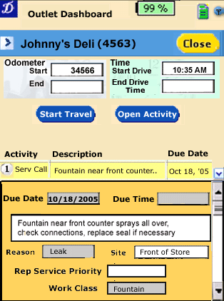
The following show examples of the window shade being open, as well as a detail preview for Equip Inv activity.
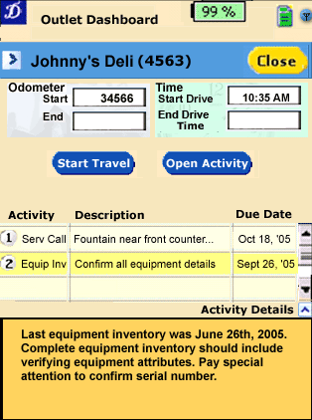

Perform Service Wizard
Description of Functionality
- This perform service wizard provides a series of steps that the rep goes through in performing the service and complete the work report. The wizard is started by double tapping or tapping Open button on the service call activity on the outlet visit.
- The Wizard steps include:
    - Start Work
    - Review Update Details
    - View dispatcher note and update technicians note
    - Captured parts used, returned, missing
    - Capture accessories installed and/or removed
    - Enter reason codes
    - Time & Mileage - Enter work report completion information (time, etc.)
    - Indicate completion
    - Preview work report
Finish – capture signature and print final copy.
- The wizard provides an “expert mode” that allows the rep to jump to any of the above steps.
- Each wizard screen allows the rep to go to the next step, go to the previous step, or “”Finish”. The Finish selection can be set to only be enabled based on the completion of certain steps.
- Finish will not be available unless the Finish Work above is complete.
- A rep can exit the wizard prematurely by selecting “Close”. The user will be provided a configurable level warning where they are provided the option to either save their work report as is, or discard the changes. It is possible for the rep to save the changes while they go to another outlet, perform service, and then return to complete this report.
- Edit ability of various steps is dependent on the state of the service call.
    - If the rep is in either Interrupted Day or Ended Day all service calls are read only.
    - If the service call is the primary call, it is in the accepted state and start travel state is configured ON, then no steps can be editable. The rep must select the primary service call on the outlet visit and initiate a start travel. If Started Travel state configuration is turned off, then the rep an initiate the Start Work step only. Other steps are read only. The service call is not primary the rep must initiate the Start Work step for the service call to become editable.
    - If the service call is in started travel state, then the then the rep an initiate the Start Work step only. Other steps are read only.
    - If the service call is in Started Work state, then the rep can perform all steps after start work step, except Finish based on the availability of finish as defined above.
    - If the service call is in Complete state. All steps are read-only.
- All of the screens within the wizard provide the ability to tap on the outlet bar and they will be taken to the outlet details screen
- All of the screens within the wizard provide the ability to tap on the equipment bar and they will be taken to the equipment details screen
- If display of outlet/equipment details is requested (see VIII and IX) and only basic data is present for this outlet, a pop-up window “Get Outlet/Equipment Data Onboard” prompts the rep for download of full data. Details can only be shown when download is complete.
- Special handling of shop-work activities:
- Shop work activities are identified through activity type “Shop work” (= “9” in BASIS EC)
- no outlet number is needed for shop-work, a dummy outlet number for the warehouse is added by the connector for BASIS EC (from XI30).

Configurability
- Order of the steps in the wizard. Which steps are provided. For example, if an implementation does not use accessories that step could be removed.

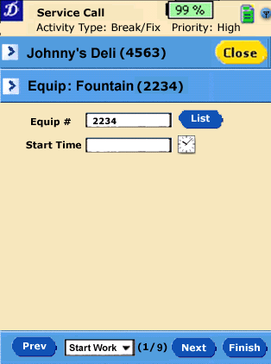
Perform Service Wizard - Step 1
Description of Functionality
- This screen is reached from by double tapping or tapping Open button on a service call in the outlet visit activity list.
- The rep can scan the equipment which sets the equipment number.
- Alternatively, the user can enter the equipment number.. The rep can tap on the List button and select form a list of equipment that is installed at the outlet.
- Next button (or expert choices) are made enabled when
  - Service call is in Started Work state or Complete state
  - If Service Call is Primary activity and it in Started Travel state
    - If scanning is required, equipment must be scanned or reason code for not scanning
    - If scanning is not required , it is available immediately upon entry to this wizard step.
  - Service call is not primary and it in Accepted State
- When status is in Accepted (Started Travel not configured) or Started Travel, then service call is set to the “Started Work” state, and sends start timestamp to back office when Next or Expert step is selected.
- If when entering this screen the Start Time is not set, it is defaulted to the system time.
- If equipment number is not set upon entry to this screen, equipment link should show “Unknown” Once known equipment number is entered link becomes active to equipment detail.
- Upon “Next” or moving to another step –
- Unless the service call is in Completed state, it is set to Started Work state.
- If the entered equipment number does not exist a configurable warning/error is generated. The invalid equipment number would be flagged in the connector as an exception – this exception will be logged. The connector will first retry to verify the equipment number.
- In the case where the master data does not show equipment as present in the outlet (e.g. they have entered an outlet number then scanned) a configurable error/warning is generated. This mismatch would be flagged in the connector as an exception – this exception will be logged. The connector will retry again without the equipment number
- If scanning is required and the equipment was not scanned then a reason must be entered for as to why scanning was not done.
- If equipment number is required an error is generated and the Next button is only enabled when entered.
- The equipment sighting record should be updated with the current date when the service call enters the Started Work state (last sighting date and last scanned date if applicable).

Configurability
- Whether a scan is required to start work If this is set to be required, the rep can manually enter the equipment number but they would be required to enter a reason code as to why is did not scan.
- Scanning also automatically fills in the start time. Alternatively, if scanning is not used (or required) the rep can tap on the clock icon to set the start time, which also triggers the service call into the Started Work state.
- Maximum number of service calls in “New” state when a service call enters “Started Work”. In some cases bottlers want to force the rep to either accept/reject any New service calls prior to starting their next service call. If there are more service calls in the New state, the system should provide an error message using the configurable error mechanism.
- Whether equipment is a required field.
- Equipment number masks for scanning (see Equipment Scanning and Masks in chapter 9. Sync). If more than one mask applies the tech can select one in a pop-up window.

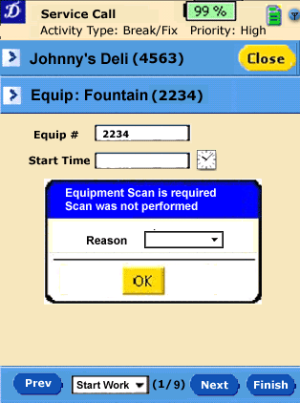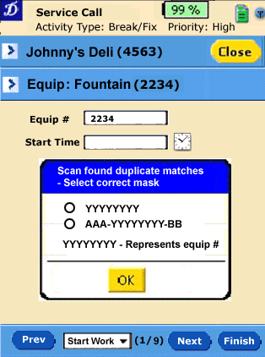

Perform Service Wizard - Step 2
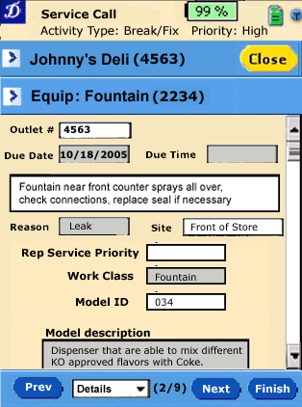
Description of Functionality
- This provides the rep the ability to review all the details of the service call and update fields as configured.
- Dependent on config options the rep may be able to update fields on this screen such as:
- Due date and time
- Rep Service Priority
- Site
- Contact person
- Contact Phone number
- Next and ability to move to subsequent steps is always enabled.

Configurability
- Select service call attributes to show
- Define which fields can be editable (NOTE: Outlet number and Equipment number are not editable.)
- Default field configuration
  - Site
  - Contact person
  - Contact number
- Changes to these fields would automatically update the equipment master back-end system.
- For off-route service calls the following fields are not available and cannot be shown and updated: Site, Contact person, Contact number when they do not download outlet info.

Perform Service Wizard - Step 3
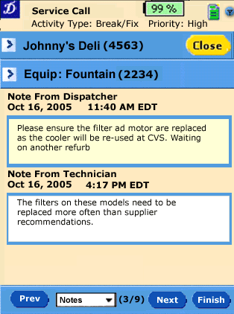
Description of Functionality
- This provides the rep the ability to read the dispatcher note and edit the technician note
- When editing Technician note cursor is placed at the end of text.
- Next and ability to move to subsequent steps is always enabled.
- Date & time on technician note is set upon last update
- Date & time on dispatcher note is set upon last update the note in the back-office

Configurability
Max length of message. Default 254.

Perform Service Wizard - Step 4
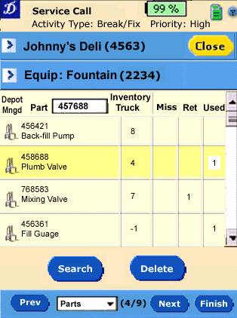
Description of Functionality
- This screen provides the rep the ability to capture spare parts used, returned, and/or missing for a service call.
- The list start empty. Parts can be added by either entering or scanning part number, or clicking on “Search”. If the rep types in a part number that does not match any in the parts master, they are prompted with an error indicating the part number does not exist (configurable levels) as to whether they want proceed. DEV NOTE: Optimize use of lines perhaps putting single rows. Alternately could move search/delete buttons up. Aslo indicator that <ENTER> is used to complete manually entered part numbers (use button or icon)
- The rep can enter quantities in the Miss, Ret, and used columns to indicate part missing, returned, or used in service call. A part can have any or all of the columns filled in.
- When adding a new part using the keyboard, the cursor defaults to the “Used” column.
- Truck inventory column is read only. It gets updated as a result of completing a work report, whereby used parts are subtracted, and returned parts are added. Since the base value for truck inventory comes from the BASIS and is not real time (perhaps updated daily), it is possible that it is out of date to the physical inventory and the value could be less than zero. In the case of shop work, a rep’s truck inventory should NOT be adjusted as the parts will be drawn from the depot’s stock.
- Icon shows parts that are managed in the rep’s local depot. If not managed at depot ,truck inv will be zero, and these parts can only be set to missing (cannot mark returned/used)
- Items with no entries (missing, returned, used) are saved even upon exit of service wizard. They get deleted when the work report is completed, and do not show up in the completed work report.
- If rep enters a part number that does not exist, they get a configurable warning.
- If the rep enters a part for which they are not marked as managed by rep (but is managed at spare parts depot) they get a configurable warning.
- Next and ability to move to subsequent steps is always enabled.
- Keyboard navigation show allow left, right, down, up, and enter control keys. Enter moves cursor to part entry field..
- Actions
- Search – launches to a parts search page that allows the rep to search for parts to add to this list.

- Delete – Deletes line from list.

Configurability
- None – a warning for the if the truck inventory is going below 0.

Perform Service Wizard - Step 4a – Parts Search
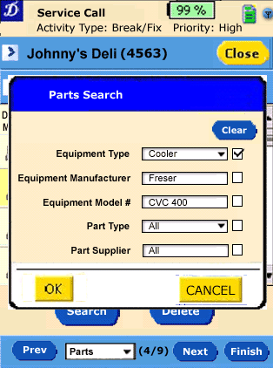
Description of Functionality
- This screen provides the rep the ability to search for part types based on part attributes.. DEV NOTE: Could be pop-up window
- The filter allows up to 5 part attributes to be used for search criteria
- The user can select which fields are saved for search. These would be saved and the same each time this screen is launched. For example in this case Equipment Type = Cooler would be saved and would appear each time this screen in launched. Whereas, Equipment manufacturer would be blank. The setting to Freser is only effective for this search.
- Actions
  - Clear – clears search criteria, including those saved. Proceeding would provide a list of all spare parts.
  - OK – Initiates search for parts matching search criteria.
  - Cancel – Takes the user back to screen from which this was launched (parts screen in service wizard or spare parts hub)
- The fields can be either multi-select through drop down or string match. Even in the case where there may be a fixed set of values the functionality may be string match as providing a lookup for 50 potential values is out of scope. For example, if there are 50 different valid model numbers instead of providing a drop down or ability to select from the 50, the search will simply be done on text string entered and matched against the 50 possible model numbers.

Configurability
- Select part attributes to use in Part Search. Attributes types can be numeric, text, and list. The fields that appear in the screen example derive from the Spare Part Grouping Codes 1-10 which can be fully customized in BASIS in regards to meaning, values and associated code interpretations. Also the field names can be localized accordingly, e.g. Equipment Type = Spare Part Grouping Code 1, Equipment Manufacturer = Spare Part Grouping Code 2, Equipment Model = Spare Part Grouping Code 3, Part Type = Spare Part Grouping Code 4, Part Supplier = Spare Part Grouping Code 5. NOTE: For large lists, they should be set to numeric or text to avoid long scrolling drop downs.

Perform Service Wizard - Step 4b – Parts Search Results
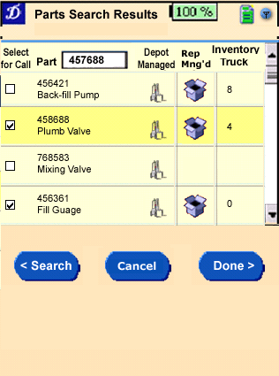
Description of Functionality
- This screen provides the results of the search for part types based on part attributes. .
- Entering a part number of partial part number selects the first line that matches.
- The user can select one or more parts by checking the select box in the left column. These will be added to the parts list from the list where the search was launched from
- DEV NOTE: Use entire screen for list of parts.
- There is an icon which indicates whether the part is managed by the rep.
- Actions
- Search – returns to search criteria. Any selected items when doing new search get added to the parts list.
- Done - returns to parts tab with selected parts added to list. Cursor on first added row.
- Cancel – returns rep to screen from where parts search was launched

Configurability
Configurable warning if the rep uses a part and it results in the truck inventory becoming negative.

Perform Service Wizard - Step 5
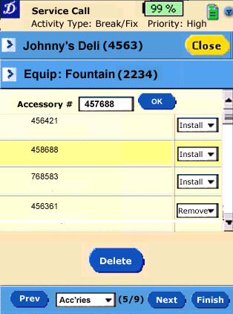
Description of Functionality
- This screen provides the rep the ability to indicate which accessories have been installed or removed
- List starts empty
- Accessories can be added to list by entering accessory number or scanning bar code. Hitting OK indicates in the accessory number is complete. Alternatively the keyboard action <Enter> could be used.
- Choices in drop down are “Install” or “Remove”. Default action shows accessory as installed.
- Each line represents a specific accessory with its accessory number shown in the left column. No description is provided.
- Next and ability to move to subsequent steps is always enabled.
- Actions
- Delete – deletes selected line

Configurability
None

Perform Service Wizard - Step 6
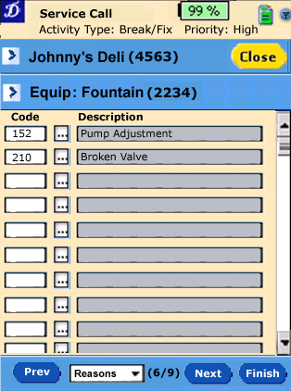
Description of Functionality
- This screen provides the rep the ability to specify up to 10 reason codes reflecting the work performed. Reps know more frequent codes, but there could be hundreds available.
- Keyboard entry leverage down key (Enter) to move to next reason code.
- Entering code and hitting <Enter> fills in the description. If no code is matched an indication (audible beep) should be made.
- Alternately could search for codes by code # and/or description. Search needs to support wildcard in either code or description. Results of search would show matching codes and description, with ability of rep to select one to add to this list.
- Each reason code has its own set of valid values.
- Next and ability to move to subsequent steps is disabled until required reason codes are entered.
- Hierarchy of reason codes is not supported.

Configurability
- Codes and Descriptions are customer defined. Not HH configuration, mapping is handled in connector (mapped to Activity Grouping Codes 1-10).
- Which reason codes are required. For example, reason codes 1, 3, and 4 have specific meaning and must be filled in.

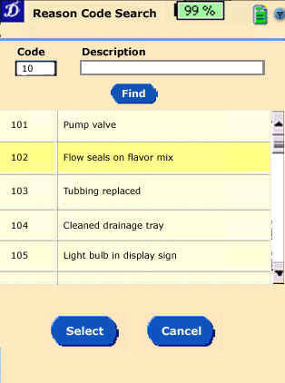

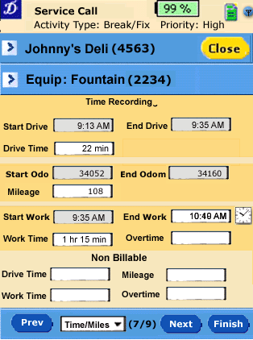
Perform Service Wizard - Step 7
Description of Functionality
- Provides rep ability to complete work report by entering work time, drive time, and overtime.
- Start Drive, End Drive and Start Work time are shown as time filled in during start work step and cannot be changed here.
- End time shows current system time by default and can be overwritten by the rep. End time must be greater than start time.
- Work time is initially calculated based on start time and end time. Rep can edit work time. .
- If no drive time is entered a warning is generated. (See fields configuration below) Rep can accept if no work time is charged to outlet.
- Overtime is rep entered and optional.
- Non-billable drive time, mileage, overtime and work time are entry fields that the rep can use to allocate some of the drive/work time as non-billable.

Configurability
- Which fields are shown (union regulations about showing time stamps)
- Which fields are required Work time and drive time are mandatory by default (warning to accept 0). Required field should be indicated, and a warning when required fields are not filled.
- Visibility of non billable attributes.

Perform Service Wizard - Step 8
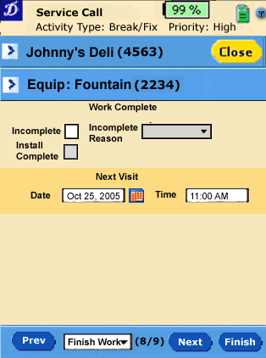
Description of Functionality
- Provides rep ability to indicate service call is complete.
- Rep can mark the work as incomplete, and if so must provide a reason code. This would be used to create a split in BASIS.
- If the work report is for an install, the “install complete” check box would be enabled to indicate whether the installation of equipment was completed. Default is “install complete”
- The rep can optionally set a next visit date and time.

Configurability
None

Perform Service Wizard - Step 9
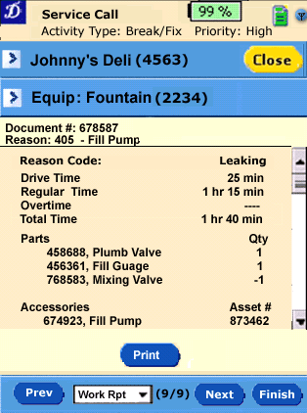
Description of Functionality
- Shows details for work report. Details required for on screen work report include
- Document number
- Reason code – as assigned by dispatcher
- Rep entered reason codes and descriptions.
- Drive Time
- Regular work time
- Overtime (if applicable)
- Total time
- Parts used and returned
- Accessories installed and removed
- If customer is billable and there are non-billable values. These should be shown and printed.

- Actions
- Print – prints a draft work report if status <> complete, otherwise prints final. See separate print spec for format of printed reports.

Configurability
None

Perform Service Wizard - Finish
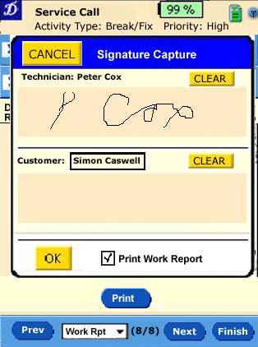
Description of Functionality
- This screen is launched by tapping on the Finish button, once it is enabled based on the defined criteria (defined earlier).
- Captures both customer and technician signature for work report
- Customer name to be typed in.
- Actions
- CLEAR – Clears signature
- Cancel - Returns to service call wizard screen from where it was launched. Service call remains in “started work” state.
- OK – Confirms signature and completes work report. Returns user to outlet visit. No more changes to work report/service call details.
- Development Note: Ensure signature space is large enough, and keys cannot be tapped will signing. Options split two sigs across screens, flip signature upside down for customer (ala Tasty)
- Option to print final work report with signatures is provided. This is default checked.

Configurability
- Warning for no signature.
- Shows details for work report. Details required for on screen work report include

Outlets and Equipment

Outlet List
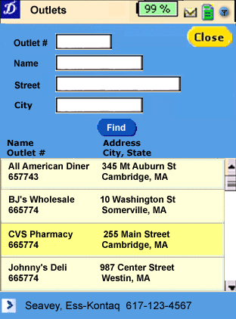
Description of Functionality
- This screen is launched by tapping on the Outlets button on the main visit.
- The outlet list starts empty and is filled when “Find” is tapped.
- The rep can search by same criteria as when searching during new service call as well as:
  - Outlet number

Entries are logically ANDed together. Partial entries can result in multiple outlets found. For example, entering CVS in name could resulting in finding CVS Pharmacy and CVS – Connecticut Vocational School.
→ Can we also apply the entered outlet number as wildcard, e.g. 800 finds 800237, 128005 and 9800. This is currently supported for the dispatcher at CCEAG. Nice to have

- Actions
  - Find – applies the input filter criteria and populates the outlet list
  - Close – returns user to main visit.

If the outlet number entered is not loaded on board the handheld, the user is given on option to download all the outlet details and associated equipment to the handheld at that time( Seem below). This is the same behavior as when the user is creating a new service call.

The user can tap on the outlet link at the bottom of the screen or the double tap on the row and they will be taken to the outlet details screen.

Configurability
- Which attributes are displayed in grid

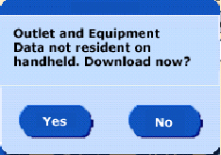

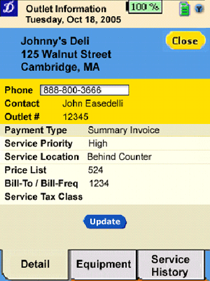
Outlet Details
Description of Functionality
- This screen is launched from a number of places in the application. Where-ever there is a link to outlet details.
- This screen shows outlet details such as address, contact information, outlet hours, etc.
- The handheld maintain a list of all outlets with name and address information for a service call. However, only the outlets and equipment for assigned service calls will be downloaded. These get purged when the service call is purged. As a result in viewing the outlet details tab if the outlet # is not within the technician’s service location, only the basic information (outlet#, name, address) are downloaed and as a result most of the fields may be blank, and the equipment tab will be empty.
- Update – the update button retrieves outlet detail and equipment information on demand from the server.
- These fields are all read only

Configurability
- What outlet attributes to display, and in what order.

Outlet Equipment List
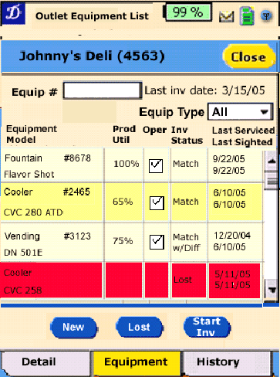
Description of Functionality
- This screen is launched by either tapping on the equipment tab of the outlet detail screen, or from the outlet visit when starting an equipment inventory.
- Represents all equipment present in an outlet.
- Whenever an equipement is sighted the Last Sighted date should be updated as well as the rep ID of the user who perfomed the sighting.
- Scanning equipment selects the equipment.
- Rep can update prod utilization fields per equipment directly in the grid. Values 0-100% represent how much KO product is present.
- Rep can mark equipment as operational or not directly in the grid. Default is operational.
- If new equipment is scanned open “New Equipment ” window”.
- Inv Status – gets reset on “Start Inv”, when a sighting is done and data is updated, or when master data gets updated from back-end.
- Actions
- Match – (new button) sets Inv Status to Match regardless of whether an equipment inventory has been started or not. A reason code pop-up is presented if scanning is required and has not been performed.
- New – provided to enter newly found equipment at outlet. When a newly added piece of equipment is in the list and it is selected this button becomes Delete. If a piece of equipment is scanned and not already in the equipment list, the new equipment window should open automatically.
- Lost – marks select piece of equipment as lost. Only enabled if a piece of equipment is selected, and the status is not “New”. When equipment is marked as lost. The user must enter a reason code, and optionally a description. The sighting record gets updated with thisinformation as well as the rep ID.
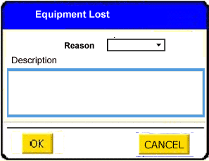
- Start Inv – Starts an equipment inventory. When equipment is scanned (or entered) navigates to detail screen to validate equipment attributes. During equipment inventory, button is “End Inv”. If some of the equipment has already been sighted (scanned or manually set to match) on current date their inventory status will not be reset. The rep will not be required to perform a detailed comparison for these already sighted pieces of equipment.
- Last inv date is the last date a complete equipment inventory was performed. (Note: Logically this is an outlet attribute, however to facilitate synch each equipment sighting status will be updated. What is shown here should be the oldest equipment inventory date.
- Valid inventory status includes:
  - Match – Master data is correct.
  - Match w/Diff – Master data is incorrect. Correct data is captured in sighting record.
  - New – No master record for this equipment at this outlet
  - Lost – Equipment cannot be found at the outlet. Exists in master data.
- Close – If an equipment inventory is being performed (and has not been completed) a configurable warning is provided. If the rep proceeds, the equipment items that have been inventoried retain with the status as completed. Inventory status for remaining equipment is left Open (blank). In such a case the last inv date would not be updated.
- Double tapping on equipment takes the rep to the equipment detail screen

Configurability
- Which attributes are displayed in grid. It must also be possible to customize the two editable attributes for “Product Util” and “Oper”?.

Equipment Details
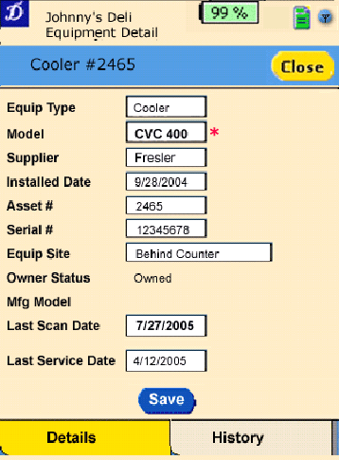
Description of Functionality
- This screen is launched by either double tapping on the outlet equipment summary, or through-out the application where the equipment details tab is available.
- Shows equipment detail (Note: need to show edits clearly).
- Rep can correct fields based on configuration. Updated fields should be highlighted.
- Actions
- Save – only enabled if rep has changed an editable attribute.
- Close – returns rep to screen where this screen was launched from. If changes have been made to fields and save has not been made, a warning to user is provided to exit and discard the changes or not exit. If changes are made and confirmed, then the Inv Status should be updated.

Configurability
- Which equipment attributes are visible
- Which attributes are editable by rep. Default editable
  - Model
  - Serial number
  - Site location
  - Equipment contact
  - Contact phone number

New Equipment Found
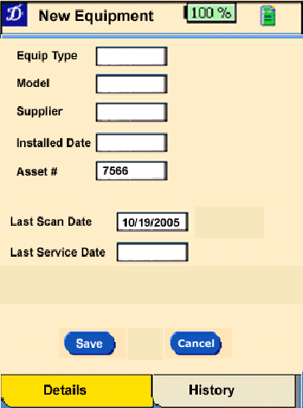
Description of Functionality
- This screen is launched by either indicating new found equipment on outtet equipment summary screen or during a perform service call, whereby the equipment scanned/entered is not listed in the outlet’s equipment summary.
- If this screen is launched by scanning and multiple masks are configured, the user is prompted to select which mask they have scanned. They must select a mask. Once selected the equipment number is pre-populated (without prefix or suffix)
- Provides ability to rep to enter key equipment attributes for new equipment,
- Actions
- Save – only enabled if rep has entered required attributes.
- Cancel – returns rep to screen where this screen was launched from. If changes have been made to fields and save has not been made, a warning to user is provided to exit and discard the changes or not exit. Also any required fields must be completed.

Configurability
Which equipment attributes are visible - Note: Equipment number should always be first!!

- Which attributes are editable by rep
- What attributes are required.
- Equipment number masks for scanning (see Equipment Scanning and Masks in chapter 9. Sync). If more than one mask applies the tech can select one in a pop-up window (same as in Perform Service wizard – Step 1)

Equipment Service History
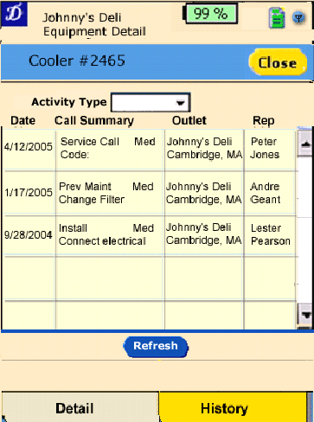
Description of Functionality
- Provides service history for specific piece of equipment.
- Filter on activity Type
- The history could include service calls from another outlet
- Actions
- Refresh – pulls latest equipment history from OC.
- Close – Same as for equipment detail

Configurability
- Which attributes are displayed in grid.
- On server config max history records downloaded based on last x weeks, with max y records. Y= means no limit

Outlet Service History
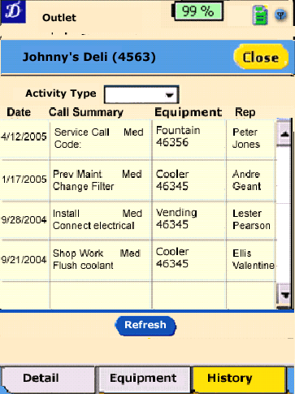
Description of Functionality
- Provides service history for an outlet.
- Filter on activity Type
- Actions
  - Update – pulls latest outlet history from OC.
- Note : KO does not have rep who did service in their history, or the equipment type.

Configurability
- Which attributes are displayed in grid.
- On server config max history records downloaded based on last x weeks, with max y records. Y=o means no limit

Spare Parts

Spare Parts
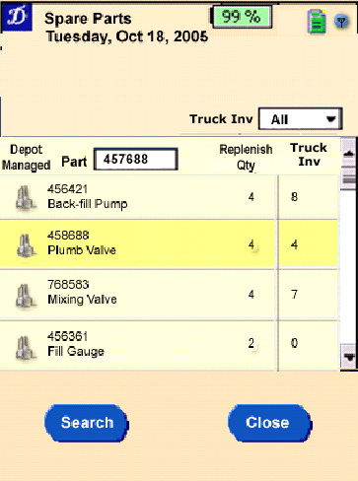
Description of Functionality
- This screen is launched by tapping on the Spare Parts button on the main menu.
- Provides visibility to spare part inventory managed by rep. Currently updated by back-end, and adjusted based on service calls and parts used/returned.
- The ”Replenish Qty” column represents the value at which the rep should be getting additional stock for this part.
- Part number can be entered or scanned to position to item entry. → OK button next to part # field???
- The Filter on “Truck Inv” includes:
- On truck (Truck Inv qty > 0)
- Not on truck (Truck Inv qty <= 0
- Below replenish quantity (Truck Inv qty < replenishment quantity)
- Actions
- Search – same as search within service call.
- Close returns rep to main dashboard.

Configurability
- Which attributes are displayed in grid.

Begin/End Day

Overview
There are three concepts that relate to start of day and end of day:
- The rep may be in one of the following work day states: Working Day, Ended Day and Interrupted Day. Each of these states involve specific actions the rep must take. Initially (this release) the steps are simply collecting time and odometer readings. When the rep is in either Ended Day or Interrupted Day they can view the work list and service calls, but cannot edit them. They must be in working day state to edit and perform work.
- Available and Unavailable: This is simply an indicator the rep makes to notify the dispatcher whether they are available or not. The handheld does not enforce any rules such as blocking messages or service calls if the rep has marked themselves as unavailable. When the rep marks themselves unavailable or available, they will be required provide a reason code which will trigger the appropriate action based on the work day state.
- Sign on and sign off. This represents whether the user is signed on or off of the handheld application. When a rep signs off they will forced to indicate they are unavailable with he same reason codes and logic above. Similarly when they sign on they will be prompted to resume their day or start the day based on their work day state

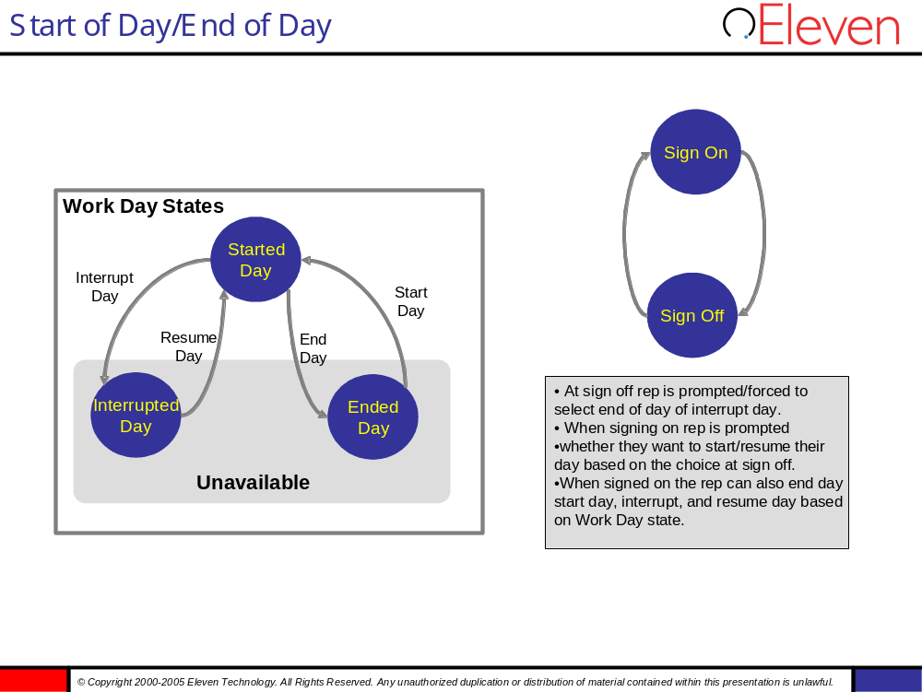

Start of Day/End of Day
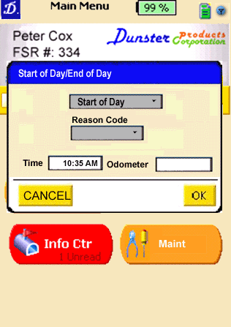
Description of Functionality
- This pop-up is reached in a number of circumstances.
- From the top of the screen on any page the rep can tap the blue availability icon.
- When signing on to the application the user is prompted to make themselves available. To avoid making themselves available they tap Cancel, and are taken to the Main Menu.
- When signing off use is prompted for an action. Options include End of Day or Interrupt Day. Cancel button is available to remain in current state.
- The valid actions are dependent on the Work Day State.
- When in Working Day the actions are: End of Day or Interrupt Day
- When in Ended Day the actions are: Start of Day
- When in Interrupted Day the actions is Resume Day. These are set by the application based on the work day state.
- When rep is performing Interrupt Day action a reason code is required.
- Time and odometer readings are captured any time the rep changes Work Day status.
- Time is default set to system time
- Odometer default is set from last recorded odometer. For example, at begin of day default should be previous end of day, for resume day should be previous interrupt day, for end of day should be ending odometer of last service call, etc.
- Time and odometer may be required fields depending on a config option. If required, OK is not enabled unless these are completed.
- When the rep is in either Ended Day or Interrupt Day states, the server should send a unavailable message to the back-end. Similarly when the rep enters the Working Day state they should be marked as available.
- If the rep is performing the End of Day action and they had work reports in either Started Travel or Started Work state they are presented with a configurable warning. If rep accepts the warning the uncompleted calls remain in their current status and can be resumed by the rep any time later. If the warning is upgraded to an error the rep cannot end the day unless he has resumed and completed these calls.

Configurability:
- Whether time and odometer fields appear for Interrupt Day and Resume Day actions.
- Whether time and odometer are required can be defined for each of the three actions Start Day, Interrupt and End Day.

Sign On
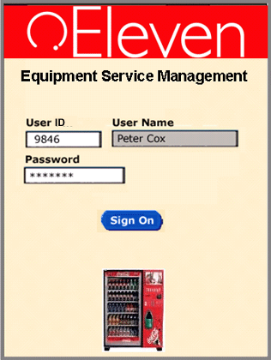
Description of Functionality
- This screen is launched when the application is started. Provides sign on for user.
- The current user ID is prompted by default, i.e. user who last signed on. At first sign-on after installation the user ID remains empty and must be entered by the rep.
- Any user of the service location can sign on to the device. Based on user role, a number of things can occur.
- Current owner, whose data is on HH –last successful non-admin sign on. Normal login. No lost password support. Rep needs to phone support desk to get old password and have it reset. No access to other applications or file system
- Administrator (defined in user profile). When admin successfully logs into application they can work with the current user’s data. They will also have access to other applications and file system from within the ESM application. The current user’s name will be displayed on all application screens such as on Main menu and on Daily Summary screen.
- New user. Warning to indicate this is not their device, with a choice to proceed. Proceeding will download new user’s data to handheld, eliminating previous user’s data.
- User is prompted to with Start of Day prompt..
- User authentication must launch an invalid user ID/password error pop-up.

Configurability
- Number of failed sign-in attempts before locking user out.

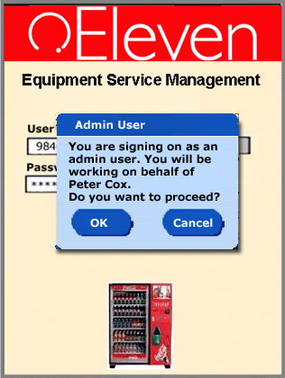
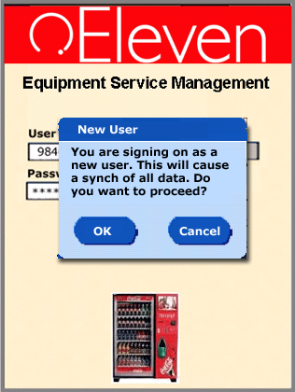

Sign Off
Description of Functionality
- Sign off is performed from the Main Menu or from the Work List.
- If the user is currently set to Available, they are forced to set themselves as unavailable first. Rep chooses either End of Day of Interrupt Day as reason. This is done through the Set Availability pop up.
- Dependent on whether the sign-on user is allowed to access they will either be taken back to the sign-on screen, if no access to O/S is allowed, or the application closes completely and they will have access to the O/S and other applications, One config option can be set to allow all or no users to access the operating system. Admin users can always access the O/S regardless of this option.

→ still an open issue how you can access the O/S from within the running the application, e.g. rep needs to phione someone and needs access to address book!

Configurability
- Access to operating system for normal users. Option should be configurable per user group. Admin users must always be able to access the O/S regardless of this config option. Need input from Shawn.

Daily Summary
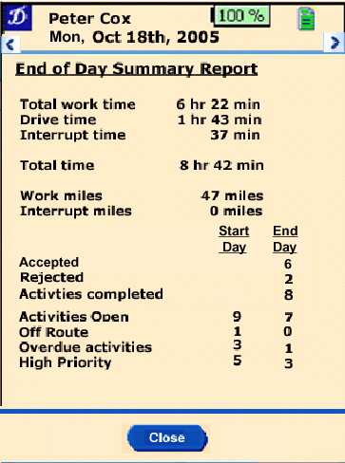
Description of Functionality
- This screen is accessed by tapping on the work day summary bar on the main dash
- This screen provides a daily summary report of activities
- The rep back review past reports for as many days back as are configured based on history.
- Actions
  - Left arrow (top left screen) moves to previous day
  - Right arrow (top right screen) moves to next day
  - Close – returns rep to main dash

Configurability
- Which of fields shown are present on screen.

Info Center

Message Summary
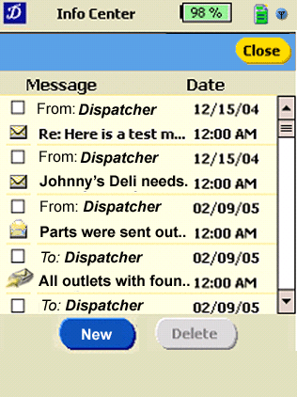
Description of Functionality
- This screen is launched by tapping on the Info Center button from the main dash.
- Provides summary of messages both received and sent.
- Actions
- New – Creates a new message – sent to dispatcher.
- Delete – Provides ability for rep to delete messages sent from or to dispatcher
- Close – returns rep to main dash.
Configurability
None

Received Message Detail
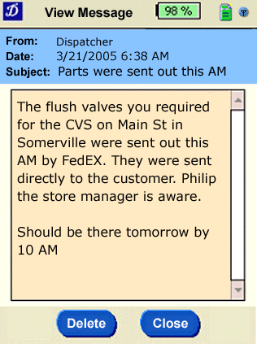
Description of Functionality
- This screen is launched by tapping on a received message from the dispatcher.
- Actions
- Delete – Provides ability for rep to delete messages sent from dispatcher
- Close – returns rep to message summary list.
Configurability
- Length of message and subject. Currently BASIS has no subject concept so we would pull first X characters out of message for subject, then repeat the whole message in the body (for clarify)

Send Message
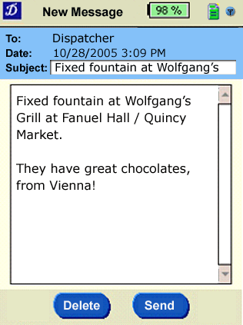
Description of Functionality
- This screen is launched by tapping on the New button on the message summary screen.
- Send new message to dispatcher.
- Actions
- Delete – deletes message and returns to summary
- Send – Sends message.
Configurability
- Need to concatenate message with subject based on max message length in BASIS.

Admin

Admin - System
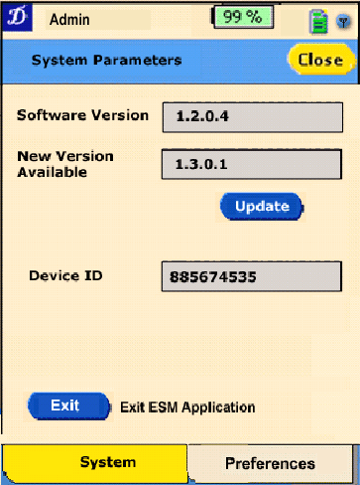
Description of Functionality
- This careen is accessed by tapping on the Maint button from the main dash.
- Provides view of system parameters for device management
- Actions
- Update – downloads new available software. Software update button enabled only available if new software is available. A warning prompts the user to inform them the handheld will be rebooted. (currently a open design question whether this is one step or two)
- Exit – only available for admin users. Allows exit of ESM application in order to access file system and any other onboard applications.
- Close – returns the rep to the main dash
Configurability
- None.

Admin – Pref
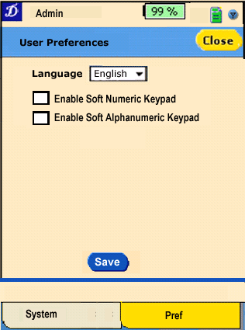
Description of Functionality
- This screen used to alter the user preferences on the device.
- By setting languages the user can choose what language the application will run in. The new language gets loaded in runtime, no other action is required.
- Depending on the hardware the user can also enable a soft keypad for numeric fields, and/or a soft keypad for alpha numeric fields. Hen enabled these keypads automatically pop-up when the user goes to enter data into either a numeric or alpha-numeric field.

Sync

Sync
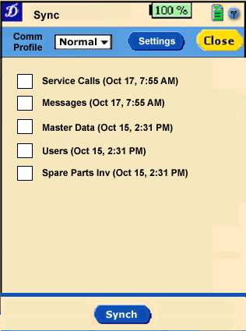
Description of Functionality
- This screen is accessed by tapping on the sync button from the Main menu screen
- The screen allows the rep to initiate a synch to pull the latest data down from the consolidated server database. The data categories include
- Service calls – All service open calls assigned to this user, and any completed service calls/work reports based on the configured history of completed service calls to be maintained on the handheld.
- Messages – All messages configured to be maintained on the handheld
- Master Data – Associated outlet, equipment, spare part master (?other) data.
- Spare parts inv – Inventory quantities for spare parts the rep should be managing
- The date/timestamp reflects the last successful sync of the data set.
- Actions
- Sync – Synchs selected data categories
- Settings – Allows the rep to review and update communications data settings.
- Close – returns the rep to the main dash
Configurability
- Reminder to download master data if it has not been downloaded in X days..

→ Ernst: not checked this screen!

Sync – Comm Settings
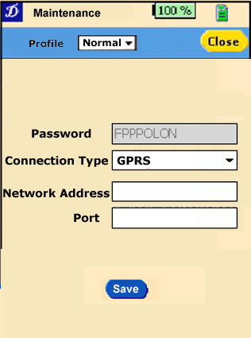
Description of Functionality
- This screen used to set the comm. Settings required to synch.
- User can define multiple connection profile types and set their default comm profile. For example, they may have one set for GPRS and another for Wifi. Their default would be GPRS for when they are working, at home, etc. Whereas when they come into the depot they may set it to Wifi and perform a master data sync.
- TBD – need to determine details.

Grid Configurability
Grids are made up of 5 main areas. They are referred to as "Areas"

  - Header Area(one per grid)
  - Group Header Area (repeatable: one per group)
  - Data Area (repeatable: one for every data object)
  - Group Footer Area (repeatable: one per group)
  - Grid Footer Area (one per grid)

Each area is a rectangle. Within that each of these rectangles are more rectangles. These are called "Elements." There are several different kinds of elements...
- Text Element (Shows static text - usually primarily in headers and footers)
- Data Element (Shows text based on the current underlying business object)
- Icon Element (Shows an icon - or possibly different icons based on data)
- Sub Total Element (Shows SUM subtotals in Footer areas)
- Tree Indicator Element (special "+/-" icon that when clicked expands/contracts groups)

There will be a multitude of configuration options.
Here is a list as an example (not a complete list.) Please note that these are items which, in general, are configurable.
Individual grids in the application will supply meta-data to indicate which of these items are actually configurable for a particular instance of the grid in the application. For instance, there may be application code that relies on a certain element being in the grid. In this case, the element would have limited configuration options.

- General Grid Layout:
  - -which areas are used
  - -the size of each area
  - -colors of each area (defined in the skin) -is grid footer static or scrollable

- Elements:
  - -elements which make up each area
  - -the size and location of each element
  - -alignment of content within each element -fonts of each data/text element (or conditional fonts) -forecolor of each data/text element (or conditional forecolors) -icon (or conditional icons) for each icon element -format strings (if any) for each data element (to specify formats for date, currency, etc) -border style for each element -Is the element Selectable -Is the data element Editable -what is the edit mask (text/numeric/currency/etc) -what is the max length of edited text

- Grouping:
  - -is grouping used
  - -which data property to group on
  - -are groups "collapsible" (like a tree control) -do groups start out collapsed or expanded

- Filtering:
  - -Initially which filters, if any, are applied to the data.

Equipment Scanning and Masks
Equipment scanning must support a variable length equipment code and potentially multiple equipment number formats within the same installation. The general format of the equipment bar code codes is as follows
xxx zzzzzzzzz yyyy

Where
xxx – Represents an equipment code prefix – for example a country code.
zzzzzzzz – The equipment/asset number. Could be a value up to a configurable set of characters long
yyy – A variable length suffix

The scan must match on the equipment code (zzzzzzzz). Within a specific installation there may be up to 3 different formats of the above syntax. As a result the scan should use each of these formats to verify equipment. If duplicate matches are found, an error/warning is provided.

When scanning with multiple masks are configured and equipment is not recognized (or multiple matches), the user is prompted to select which mask they have scanned. They must select a mask. The system will eliminate the prefix and suffix.

Configurable Exception Warning Levels
In a number of areas of the application a configurable error/exception I specified. For each of the instances the configuration settings available should include:
    - Error: User is blocked from proceeding.
    - Warning: User is provided a warning, provided an option to proceed or cancel.
    - Information: user is informed about the condition and once acknowledges the information proceeds
    - Silent: No indication to the user
For example, if the user if in the middle of the service call wizard, but have not completed the work report, they could hit the close button. The behavior of the application would be as follows based on the error/exception configuration:
    - Error: Message: Work report not complete, OK – returns user to wizard.
    - Warning:. Message: Work report not complete, OK – sends user to outlet visit Cancel - returns user to wizard
    - Information: Message: Work report not complete, OK – returns outlet visit.
    - Silent: No indication to the user

Transaction Data Purge
The detailed transaction data such as messages, completed work reports, should be maintained on the handheld for a configurable period of weeks. Default 2 weeks. This setting should be the same as the server setting for which detailed transactions will be maintained. The transactional data that is impacted by this setting includes:
- Messages
- Completed service calls,
- End of day summary reports.
- Outlet service history (not purged as part of server purge tasks)
- Equipment service history (not purged as part of server purge tasks)

Printed Work Report
Placeholder.

Odometer Default Values
DEV NOTE: Potentially add “Last Odometer Reading” to data model. Use this as default odometer data when collecting odometer readings. Only exception is for end of travel odometer reading in service call.

Soft Keyboard
Placeholder

Appendices

Appendix A – Handheld Service Call States
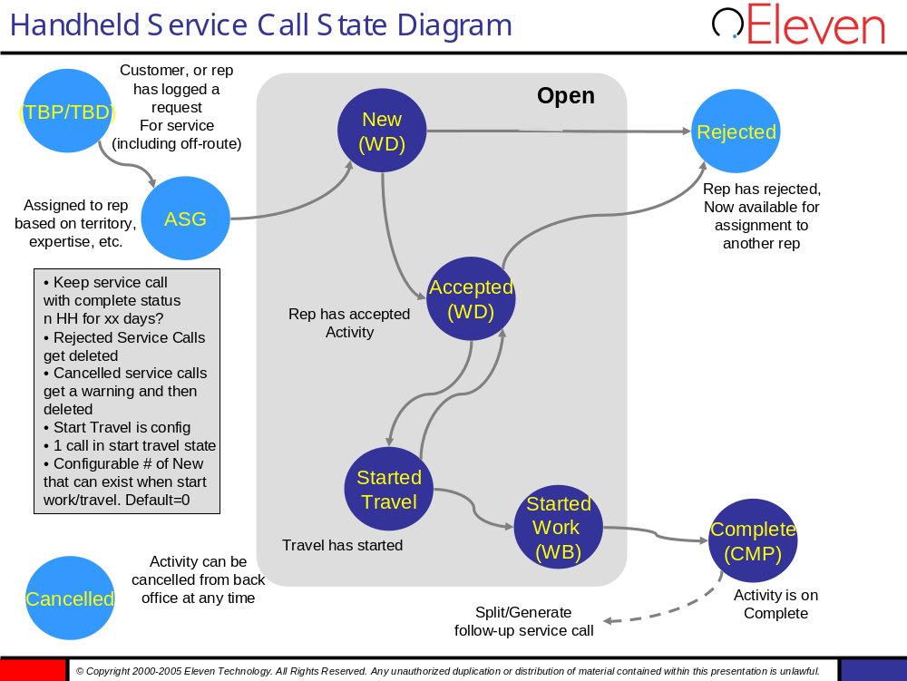

Appendix B – BASIS Service Call Types
Every service call (or called activity in BASIS) has a type which implies a particular handling and workflow within BASIS EC.
The following list shows the activity types used in BASIS EC.
Activity  Type | Name | Description
1 | Service Call | Customer calls to report malfunction. Unplanned activity to be done as soon as possible.
2 | Installation | Install new equipment at an outlet. Planned activity with a scheduled date/time.
3 | Removal | Remove equipment from an outlet. Planned activity with a scheduled date/time.
4 | Move at Outlet | Move equipment from one place to the other at an outlet. Planned activity with a scheduled date/time.
5 | Follow-up Visit | If second visit is required to check or to do additional work. Planned activity with a scheduled date/time.
6 | Special Event Installation | Special event has a known start and end date. Installation and removal can already be planned in advance. Planned activities with a scheduled date/time.
7 | Special Event Removal
8 | Preventive Maintenance | Agreed with customer in a service contract.
9 | Shop Work | Any service work done to equipment in the warehouse. Can either be planned or unplanned.

